|  |  |
| --- | --- |
| Question | Indicator |
| How market is big? | Number of EV owners  Number of EV charge station companies  Number of EV charging stations  Goal of market |
| How about infrastructure? | Number of EV chargers  Types of EV chargers  Number EVs |
| How about incentives | Public incentives  Company incentives  R&D incentives  Public charger pricing |
| Geographic situation | Geography for infrastructure  Geography for innovation & technology  Geography for economy |
| How about customers? | Education level of the customer  Customers’ sensitivity to environment |

# Market

California is the largest American car market and also the leading PEV market in the country with about 40% of all new plug-in electric vehicles sold nationwide during 2011 and 2012, while the state represents about 10% of all new car sales in the country.[[162]](http://en.wikipedia.org/wiki/Plug-in_electric_vehicles_in_the_United_States#cite_note-162) As of December 2014, a total of 129,470 plug-in electric vehicles have been registered in California between December 2010 and December 2014, representing about 45% of all plug-in cars sold in the U.S. since 2010.[[163]](http://en.wikipedia.org/wiki/Plug-in_electric_vehicles_in_the_United_States#cite_note-Cal2014-163) During 2014 California's PEV market share reached 3.2% of total new car sales in the state, up from 2.5% in 2013, while the national PEV market share in 2014 was 0.71%. Registrations of plug-in electric cars in the state in 2014 represented 50.1% of total PEV sales in the U.S. that year.[[163]](http://en.wikipedia.org/wiki/Plug-in_electric_vehicles_in_the_United_States#cite_note-Cal2014-163)[[164]](http://en.wikipedia.org/wiki/Plug-in_electric_vehicles_in_the_United_States#cite_note-Calif4Q2014-164)

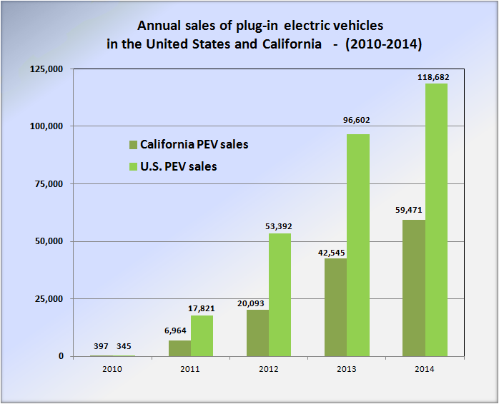

Comparison of annual sales of plug-in electric vehicles in the United States versus California between 2010 and 2014.[[131]](http://en.wikipedia.org/wiki/Plug-in_electric_vehicles_in_the_United_States#cite_note-HybridCars2014-131)[[164]](http://en.wikipedia.org/wiki/Plug-in_electric_vehicles_in_the_United_States#cite_note-Calif4Q2014-164)

**As of December 2014, California not only has more plug-in electric vehicles than any other American state but also more than any other country in the world,**[**[163]**](http://en.wikipedia.org/wiki/Plug-in_electric_vehicles_in_the_United_States#cite_note-Cal2014-163) and its market share is surpassed only by Norway and the Netherlands.[[163]](http://en.wikipedia.org/wiki/Plug-in_electric_vehicles_in_the_United_States#cite_note-Cal2014-163)[[164]](http://en.wikipedia.org/wiki/Plug-in_electric_vehicles_in_the_United_States#cite_note-Calif4Q2014-164)[[165]](http://en.wikipedia.org/wiki/Plug-in_electric_vehicles_in_the_United_States#cite_note-Global700K-165)

California is the leading Volt market and accounted for almost 23% of Volt sales during the second quarter of 2012, followed by Michigan with 6.3% of national sales. The leading regional markets in California were [San Francisco](http://en.wikipedia.org/wiki/San_Francisco), [Los Angeles](http://en.wikipedia.org/wiki/Los_Angeles), and [San Diego](http://en.wikipedia.org/wiki/San_Diego), all metropolitan areas notorious for their high congestion levels and where free access to high-occupancy lanes for solo drivers has been a strong incentive to boost Volt sales in the state.[[170]](http://en.wikipedia.org/wiki/Plug-in_electric_vehicles_in_the_United_States#cite_note-170)

California is the largest American market for the [Tesla Model S](http://en.wikipedia.org/wiki/Tesla_Model_S).[[173]](http://en.wikipedia.org/wiki/Plug-in_electric_vehicles_in_the_United_States#cite_note-173) In March 2013, [Tesla Motors](http://en.wikipedia.org/wiki/Tesla_Motors) reported the delivery of the 3,000th Model S in California, representing around 50% of total Model S sales in the U.S.[[174]](http://en.wikipedia.org/wiki/Plug-in_electric_vehicles_in_the_United_States#cite_note-174)[[175]](http://en.wikipedia.org/wiki/Plug-in_electric_vehicles_in_the_United_States#cite_note-175)

 As of November 2013, with the Model S available nationwide, California continued to lead U.S. sales with a 48% share of national sales.[[180]](http://en.wikipedia.org/wiki/Plug-in_electric_vehicles_in_the_United_States#cite_note-180)

# Companies

As for retailers, Walgreens is by far the plug-in friendliest, with 365 stores deploying plug-in stations nationally. 55 Kohl's stores had public stations as of March 22, while Whole Foods was home to 39 stations.

# Goals

Governor [Jerry Brown](http://en.wikipedia.org/wiki/Jerry_Brown) issued an executive order in March 2012 that established the goal of getting 1.5 million [zero-emission vehicles](http://en.wikipedia.org/wiki/California_Air_Resources_Board#California_zero-emissions_vehicle) (ZEVs) in California by 2025.[[25]](http://en.wikipedia.org/wiki/Plug-in_electric_vehicles_in_the_United_States#cite_note-ZEVgoalCal-25)[[26]](http://en.wikipedia.org/wiki/Plug-in_electric_vehicles_in_the_United_States#cite_note-SFG092014-26)

## Charging stations

**As of March 2013, the United States had 5,678**[**charging stations**](http://en.wikipedia.org/wiki/Charging_station)**across the country, led by**[**California**](http://en.wikipedia.org/wiki/California)**with 1,207 stations (21.3%).**[**[19]**](http://en.wikipedia.org/wiki/Plug-in_electric_vehicles_in_the_United_States#cite_note-ChargeSta-19)**In terms of public charging points, there were 19,472 public outlets available across the country by the end of December 2013, again led by California with 5,176 (26.6%) public charging points.**[**[20]**](http://en.wikipedia.org/wiki/Plug-in_electric_vehicles_in_the_United_States#cite_note-CharePoints-20)

Public Stations Private Stations

| **Total Public Alternative Fueling Station Counts** | | | | | | | | |
| --- | --- | --- | --- | --- | --- | --- | --- | --- |
| **STATE** | **Biodiesel** | **CNG** | **E85** | **Electric* (stations/charging outlets)** | **HY** | **LNG** | **LPG** | **Totals** by State** |
| Totals by fuel | 285 | 823 | 2,603 | 9,440 / 23,967 | 13 | 73 | 2,816 | 30,580 |
| California | 50 | 162 | 78 | 2,116 / 6,702 | 11 | 15 | 231 | 7,249 |
| Texas | 8 | 68 | 124 | 574 / 1,530 | 0 | 11 | 427 | 2,168 |
| Florida | 6 | 18 | 51 | 498 / 1,200 | 0 | 1 | 68 | 1,344 |
| Washington | 16 | 6 | 5 | 471 / 1,266 | 0 | 1 | 72 | 1,366 |
| New York | 6 | 40 | 74 | 440 / 997 | 0 | 0 | 46 | 1,163 |
| Oregon | 22 | 4 | 5 | 387 / 907 | 0 | 1 | 36 | 975 |
| Illinois | 2 | 17 | 214 | 353 / 810 | 0 | 1 | 109 | 1,153 |
| Tennessee | 22 | 9 | 60 | 316 / 730 | 0 | 2 | 94 | 917 |
| Georgia | 5 | 18 | 35 | 302 / 722 | 0 | 4 | 61 | 845 |
| Massachusetts | 3 | 12 | 9 | 281 / 751 | 0 | 1 | 21 | 797 |
| Arizona | 4 | 12 | 24 | 280 / 714 | 0 | 2 | 72 | 828 |
| Michigan | 11 | 14 | 230 | 260 / 643 | 0 | 0 | 72 | 970 |
| Maryland | 1 | 3 | 16 | 255 / 599 | 0 | 0 | 18 | 637 |
| North Carolina | 23 | 22 | 11 | 218 / 525 | 0 | 1 | 84 | 666 |
| Colorado | 8 | 16 | 79 | 206 / 451 | 0 | 0 | 48 | 602 |
| Virginia | 3 | 5 | 10 | 202 / 553 | 0 | 0 | 61 | 632 |
| Minnesota | 4 | 10 | 266 | 197 / 411 | 0 | 0 | 29 | 720 |
| Pennsylvania | 4 | 30 | 32 | 188 / 329 | 0 | 1 | 58 | 454 |
| Connecticut | 1 | 7 | 2 | 174 / 349 | 1 | 1 | 16 | 377 |
| Hawaii | 8 | 0 | 0 | 163 / 371 | 0 | 0 | 3 | 382 |
| Wisconsin | 5 | 48 | 150 | 154 / 258 | 0 | 1 | 54 | 516 |
| South Carolina | 18 | 5 | 58 | 127 / 235 | 1 | 1 | 47 | 365 |
| New Jersey | 1 | 8 | 3 | 123 / 331 | 0 | 0 | 10 | 353 |
| Ohio | 7 | 32 | 125 | 115 / 204 | 0 | 3 | 69 | 440 |
| Indiana | 3 | 21 | 188 | 104 / 205 | 0 | 2 | 67 | 486 |
| Missouri | 2 | 7 | 101 | 96 / 174 | 0 | 0 | 67 | 351 |
| Kansas | 5 | 7 | 23 | 94 / 244 | 0 | 0 | 38 | 317 |
| Nevada | 2 | 6 | 19 | 91 / 279 | 0 | 3 | 34 | 343 |
| Utah | 3 | 45 | 3 | 64 / 140 | 0 | 6 | 35 | 232 |
| District of Columbia | 0 | 0 | 1 | 62 / 143 | 0 | 0 | 0 | 144 |
| Rhode Island | 3 | 3 | 0 | 60 / 160 | 0 | 0 | 5 | 171 |
| Vermont | 1 | 1 | 0 | 60 / 150 | 0 | 0 | 2 | 154 |
| Iowa | 8 | 5 | 201 | 51 / 102 | 0 | 0 | 23 | 339 |
| Alabama | 3 | 9 | 24 | 38 / 62 | 0 | 2 | 100 | 200 |
| New Hampshire | 1 | 2 | 0 | 37 / 66 | 0 | 0 | 12 | 81 |
| Arkansas | 1 | 10 | 42 | 32 / 49 | 0 | 1 | 37 | 140 |
| Kentucky | 2 | 6 | 59 | 32 / 128 | 0 | 1 | 50 | 246 |
| Maine | 2 | 0 | 0 | 30 / 48 | 0 | 0 | 12 | 62 |
| Louisiana | 0 | 18 | 6 | 28 / 56 | 0 | 2 | 31 | 113 |
| Nebraska | 2 | 7 | 75 | 25 / 46 | 0 | 0 | 27 | 157 |
| Oklahoma | 0 | 86 | 25 | 23 / 34 | 0 | 1 | 143 | 289 |
| New Mexico | 4 | 6 | 8 | 22 / 59 | 0 | 1 | 46 | 124 |
| West Virginia | 0 | 3 | 5 | 21 / 91 | 0 | 0 | 12 | 111 |
| Mississippi | 0 | 4 | 3 | 16 / 17 | 0 | 0 | 113 | 137 |
| Delaware | 0 | 1 | 0 | 14 / 25 | 0 | 0 | 7 | 33 |
| Idaho | 1 | 2 | 4 | 13 / 23 | 0 | 7 | 27 | 64 |
| Wyoming | 0 | 7 | 6 | 9 / 16 | 0 | 0 | 25 | 54 |
| South Dakota | 0 | 0 | 84 | 8 / 29 | 0 | 0 | 22 | 135 |
| Montana | 2 | 0 | 0 | 6 / 28 | 0 | 0 | 49 | 79 |
| North Dakota | 2 | 0 | 65 | 3 / 4 | 0 | 0 | 20 | 91 |
| Alaska | 0 | 1 | 0 | 1 / 1 | 0 | 0 | 6 | 8 |

*Includes [legacy chargers](http://www.afdc.energy.gov/afdc/glossary.html#LegacyChargers), but does not include residential electric charging infrastructure.

Public Stations Private Stations

| **Total Public and Private Alternative Fueling Station Counts** | | | | | | | | |
| --- | --- | --- | --- | --- | --- | --- | --- | --- |
| **STATE** | **Biodiesel** | **CNG** | **E85** | **Electric* (stations/charging outlets)** | **HY** | **LNG** | **LPG** | **Totals** by State** |
| Totals by fuel | 770 | 1,547 | 2,906 | 11,278 / 27,891 | 48 | 111 | 3,079 | 36,352 |
| California | 81 | 294 | 97 | 2,486 / 7,850 | 21 | 44 | 247 | 8,634 |
| Texas | 21 | 103 | 135 | 718 / 1,903 | 1 | 13 | 451 | 2,627 |
| Florida | 17 | 45 | 62 | 601 / 1,342 | 0 | 1 | 71 | 1,538 |
| Washington | 31 | 24 | 21 | 562 / 1,533 | 0 | 1 | 73 | 1,683 |
| New York | 37 | 114 | 84 | 520 / 1,139 | 5 | 0 | 52 | 1,431 |
| Oregon | 23 | 15 | 6 | 432 / 1,020 | 0 | 2 | 36 | 1,102 |
| Illinois | 12 | 51 | 236 | 423 / 916 | 1 | 1 | 111 | 1,328 |
| Tennessee | 37 | 17 | 71 | 385 / 904 | 0 | 2 | 95 | 1,126 |
| Georgia | 24 | 31 | 50 | 346 / 777 | 0 | 4 | 62 | 948 |
| Arizona | 78 | 36 | 30 | 318 / 802 | 1 | 7 | 73 | 1,027 |
| Massachusetts | 12 | 25 | 9 | 311 / 787 | 1 | 1 | 21 | 856 |
| Michigan | 16 | 26 | 236 | 301 / 737 | 4 | 0 | 83 | 1,102 |
| Maryland | 8 | 11 | 34 | 289 / 671 | 0 | 0 | 21 | 745 |
| North Carolina | 132 | 38 | 24 | 287 / 699 | 0 | 1 | 91 | 985 |
| Virginia | 11 | 22 | 17 | 247 / 647 | 1 | 0 | 74 | 772 |
| Pennsylvania | 6 | 52 | 38 | 242 / 389 | 2 | 1 | 79 | 567 |
| Colorado | 18 | 41 | 89 | 233 / 529 | 1 | 0 | 51 | 729 |
| Minnesota | 6 | 19 | 278 | 219 / 459 | 0 | 0 | 30 | 792 |
| Connecticut | 3 | 14 | 3 | 208 / 403 | 1 | 1 | 16 | 441 |
| Hawaii | 9 | 1 | 3 | 184 / 412 | 3 | 0 | 3 | 431 |
| Wisconsin | 6 | 60 | 152 | 177 / 309 | 0 | 1 | 57 | 585 |
| New Jersey | 5 | 27 | 5 | 159 / 371 | 0 | 0 | 10 | 418 |
| Ohio | 13 | 48 | 134 | 159 / 272 | 0 | 3 | 78 | 548 |
| South Carolina | 41 | 9 | 72 | 153 / 262 | 2 | 1 | 52 | 439 |
| Indiana | 6 | 30 | 191 | 135 / 251 | 0 | 2 | 182 | 662 |
| Kansas | 7 | 12 | 25 | 119 / 281 | 0 | 0 | 38 | 363 |
| Missouri | 5 | 20 | 105 | 115 / 205 | 1 | 0 | 69 | 405 |
| Nevada | 5 | 8 | 22 | 94 / 282 | 1 | 3 | 36 | 357 |
| Utah | 3 | 91 | 3 | 78 / 165 | 0 | 6 | 36 | 304 |
| Alabama | 5 | 25 | 32 | 71 / 110 | 1 | 2 | 102 | 277 |
| District of Columbia | 7 | 2 | 3 | 68 / 159 | 0 | 0 | 0 | 171 |
| Vermont | 1 | 3 | 1 | 64 / 155 | 0 | 0 | 2 | 162 |
| Rhode Island | 6 | 6 | 0 | 63 / 163 | 0 | 0 | 5 | 180 |
| Iowa | 9 | 7 | 211 | 62 / 114 | 0 | 0 | 23 | 364 |
| New Hampshire | 4 | 3 | 1 | 53 / 88 | 0 | 0 | 13 | 109 |
| Louisiana | 2 | 25 | 9 | 47 / 77 | 0 | 2 | 33 | 148 |
| Kentucky | 4 | 8 | 66 | 46 / 144 | 0 | 1 | 51 | 274 |
| Arkansas | 4 | 13 | 46 | 44 / 62 | 0 | 1 | 37 | 163 |
| Maine | 3 | 2 | 0 | 38 / 56 | 0 | 0 | 15 | 76 |
| Oklahoma | 5 | 106 | 28 | 35 / 49 | 0 | 1 | 143 | 332 |
| Mississippi | 4 | 8 | 4 | 33 / 35 | 0 | 0 | 115 | 166 |
| West Virginia | 2 | 3 | 9 | 29 / 102 | 0 | 0 | 12 | 128 |
| Nebraska | 3 | 11 | 79 | 27 / 48 | 0 | 0 | 27 | 168 |
| New Mexico | 8 | 14 | 12 | 26 / 63 | 0 | 1 | 46 | 144 |
| Idaho | 3 | 10 | 7 | 19 / 34 | 0 | 8 | 27 | 89 |
| Delaware | 1 | 1 | 1 | 18 / 30 | 1 | 0 | 7 | 41 |
| South Dakota | 2 | 0 | 85 | 11 / 32 | 0 | 0 | 22 | 141 |
| Wyoming | 13 | 12 | 10 | 10 / 17 | 0 | 0 | 25 | 77 |
| Montana | 7 | 2 | 2 | 8 / 30 | 0 | 0 | 50 | 91 |
| North Dakota | 4 | 1 | 68 | 4 / 5 | 0 | 0 | 20 | 98 |
| Alaska | 0 | 1 | 0 | 1 / 1 | 0 | 0 | 6 | 8 |

*Includes [legacy chargers](http://www.afdc.energy.gov/afdc/glossary.html#LegacyChargers), but does not include residential electric charging infrastructure.   
**Totals by States indicate the total number of stations for all fuel types combined. Individual stations are counted multiple times if the station offers multiple types of fuel. For Electric, the total number of charging outlets was used in the calculation.

# Infrastructure

# Incentives

**Incentives**

California has been a leader in the promotion of [plug-in electric vehicles](http://en.wikipedia.org/wiki/Plug-in_electric_vehicle) as the state has in place several financial and non-financial incentives. In addition to the existing [federal tax credit](http://en.wikipedia.org/wiki/Government_incentives_for_plug-in_electric_vehicles#Federal_government), PEVs are eligible for a purchase rebate of up to US$2,500 through the [Clean Vehicle Rebate Project](http://en.wikipedia.org/wiki/Clean_Vehicle_Rebate_Project) (CVRP).[[44]](http://en.wikipedia.org/wiki/Plug-in_electric_vehicles_in_the_United_States#cite_note-CVRPFAQ1-44) Also, [battery electric vehicles](http://en.wikipedia.org/wiki/Battery_electric_vehicles) and initially, the first 40,000 applicants that purchase or lease a [plug-in hybrid](http://en.wikipedia.org/wiki/Plug-in_hybrid) meeting California’s Enhanced Advanced Technology Partial Zero Emission Vehicle (Enhanced AT PZEV), are entitled to a clean air sticker that allows the vehicle to be operated by a single occupant in California's [carpool](http://en.wikipedia.org/wiki/Carpool) or [high-occupancy vehicle lanes](http://en.wikipedia.org/wiki/High-occupancy_vehicle_lane) (**HOV high-occupancy vehicle lane (also known as an HOV lane, carpool lane, diamond lane, and transit lane or T2 or T3 lanes in Australia and New Zealand) is a restricted**[**traffic lane**](http://en.wikipedia.org/wiki/Traffic_lane)**reserved at**[**peak travel times**](http://en.wikipedia.org/wiki/Rush_hour)**or longer for the exclusive use of vehicles with a driver and one or more passengers, including**[**carpools**](http://en.wikipedia.org/wiki/Carpool)**,**[**vanpools**](http://en.wikipedia.org/wiki/Vanpool)**, and**[**transit**](http://en.wikipedia.org/wiki/Public_transit)**buses.** ). The white access sticker is reserved for zero-emissions vehicles, while plug-in hybrids use the green sticker.[[182]](http://en.wikipedia.org/wiki/Plug-in_electric_vehicles_in_the_United_States#cite_note-CAVdecal-182) As of 9 May 2014, the 40,000 green stickers available had been issued.[[183]](http://en.wikipedia.org/wiki/Plug-in_electric_vehicles_in_the_United_States#cite_note-ARB_HOVlist-183) The green sticker limit was increased to 55,000 units beginning July 1, 2014, through the budget trailer bill SB 853.[[183]](http://en.wikipedia.org/wiki/Plug-in_electric_vehicles_in_the_United_States#cite_note-ARB_HOVlist-183)[[184]](http://en.wikipedia.org/wiki/Plug-in_electric_vehicles_in_the_United_States#cite_note-Inside062014-184) In September 2014, law AB 2013 raised the cap for the green stickers from 55,000 to 70,000 new plug-in hybrids.[[26]](http://en.wikipedia.org/wiki/Plug-in_electric_vehicles_in_the_United_States#cite_note-SFG092014-26)[[27]](http://en.wikipedia.org/wiki/Plug-in_electric_vehicles_in_the_United_States#cite_note-Green77K-27) As part of the package of bills signed into law by Governor Brown in September 2014, through SB 1275 the California Air Resources Board was mandated to draft a financial plan to meet California's goal of 1 million vehicles on the road while making sure that disadvantaged communities can participate. For this purpose CARB has to change the Clean Vehicle Rebate program to provide an extra credit for low-income residents who wish to purchase or lease an electric car. CARB also should provide assistance to [carsharing](http://en.wikipedia.org/wiki/Carsharing) programs in low-income neighborhoods and install charging stations in apartment buildings in those communities. Under SB 1275, low-income residents who agree to scrap older, polluting cars will also get a clean vehicle rebate on top of existing payments for junking smog-producing vehicles.[[26]](http://en.wikipedia.org/wiki/Plug-in_electric_vehicles_in_the_United_States#cite_note-SFG092014-26)[[27]](http://en.wikipedia.org/wiki/Plug-in_electric_vehicles_in_the_United_States#cite_note-Green77K-27)

Another bill signed into law in September 2014, AB1721, grants clean air vehicles free or reduced rates in [high-occupancy toll lanes](http://en.wikipedia.org/wiki/High-occupancy_toll_lane) (HOT) lanes. Drivers of clean vehicles already enjoyed discounted rates in some facilities, such the toll to cross the [San Francisco Bay Area](http://en.wikipedia.org/wiki/San_Francisco_Bay_Area) bridges and to use the [State Route 91 Express Lanes](http://en.wikipedia.org/wiki/California_State_Route_91#91_Express_Lanes) in [Orange](http://en.wikipedia.org/wiki/Orange_County,_California) and [Riverside](http://en.wikipedia.org/wiki/Riverside_County,_California) Counties.[[26]](http://en.wikipedia.org/wiki/Plug-in_electric_vehicles_in_the_United_States#cite_note-SFG092014-26)[[185]](http://en.wikipedia.org/wiki/Plug-in_electric_vehicles_in_the_United_States#cite_note-GCC092014-185) AB 2565 facilitates access to charging stations by requiring commercial and residential property owners to approve installation if the charging station meets requirements and complies with the owner’s process for approving a modification to the property. The law makes a term in a lease of a commercial property, executed, renewed, or extended on or after 1 January 2015, void and unenforceable if it prohibits or unreasonably restricts the installation of an electric vehicle charging station in a parking space.[[26]](http://en.wikipedia.org/wiki/Plug-in_electric_vehicles_in_the_United_States#cite_note-SFG092014-26)[[185]](http://en.wikipedia.org/wiki/Plug-in_electric_vehicles_in_the_United_States#cite_note-GCC092014-185)

As of 10 March 2014, a total of 52,264 clean vehicle rebates have been issued, for a total of US$110,222,866 disbursed, with only US$3.8 million remaining for fiscal year 2013-2014. The distribution of the rebates issued correspond to 27,210 [zero-emission vehicles](http://en.wikipedia.org/wiki/California_Air_Resources_Board#California_zero-emissions_vehicle) (ZEVs), including both [battery electric vehicles](http://en.wikipedia.org/wiki/Battery_electric_vehicle) (BEVs) and [fuel cell vehicles](http://en.wikipedia.org/wiki/Fuel_cell_vehicle) (FCVs); 24,657 [plug-in hybrids](http://en.wikipedia.org/wiki/Plug-in_hybrid) (PHEVs); 49 commercial zero-emission vehicles (CZEVs); 210 zero-emission motorcycles (ZEMs); and 138[neighborhood electric vehicles](http://en.wikipedia.org/wiki/Neighborhood_electric_vehicle) (NEVs).[[186]](http://en.wikipedia.org/wiki/Plug-in_electric_vehicles_in_the_United_States#cite_note-CVRP032014-186) The Clean Vehicle Rebate Project notes their figures do not capture all [plug-in electric vehicles](http://en.wikipedia.org/wiki/Plug-in_electric_vehicle) sold in California because not every PEV owner applies for the rebate

# Geography

# Customers

# **February 2014 Survey Report**

The Plug-in Electric Vehicle (PEV) Owner Survey is a long-term collaborative research project managed by Center for Sustainable Energy's (CSE), in coordination with the California Air Resources Board (ARB) and researchers at UT Austin's Lyndon B. Johnson School of Public Affairs and the UC Davis Institute of Transportation Studies.

Together, the project team is analyzing data from Clean Vehicle Project (CVRP) participants in order to understand trends in the PEV market, including the drivers of adoption, vehicle use, as well as vehicle charging infrastructure use and satisfaction.

The latest survey of California’s plug-in electric vehicle (PEV) drivers shows differences in primary purchase motivations from owners of one model to the next. The survey also shows increased satisfaction with public charging options and wider availability of workplace charging.

Previous rounds of the CSE survey consisted largely of all-electric Nissan Leaf drivers. This is the first time drivers of multiple vehicle types have participated: 57% Leaf, 17% Chevrolet Volt and 22% Toyota Prius Plug-in.

The current survey covers drivers who have owned their vehicle for at least six months as of March 1, 2013.

**Highlights from the survey include:**

* The primary motivations for vehicle purchase vary significantly between models – Leaf drivers claimed environment as the primary motivator, Plug-in Prius owners indicate HOV lane access and Volt drivers said fuel savings.
* Chevy Volt-driving respondents are more than four times as likely to have a level 2 charging station installed at their home than Toyota Prius Plug-In respondents.
* Workplace charging availability is becoming more widespread, 46% of respondents reported access to workplace charging, an increase of 14% from March 2012.
* Of those with access to workplace charging, 74% have access to this charging at no cost to the driver, down from 89% in March 2012.
* Though low, driver satisfaction with public charging infrastructure continues to improve, rising from 17% in March 2012 to 29% in May 2013.
* HOV lane access was an extremely or a very important purchase motivation for 59% of respondents; 84% are displaying the HOV lane access sticker.

[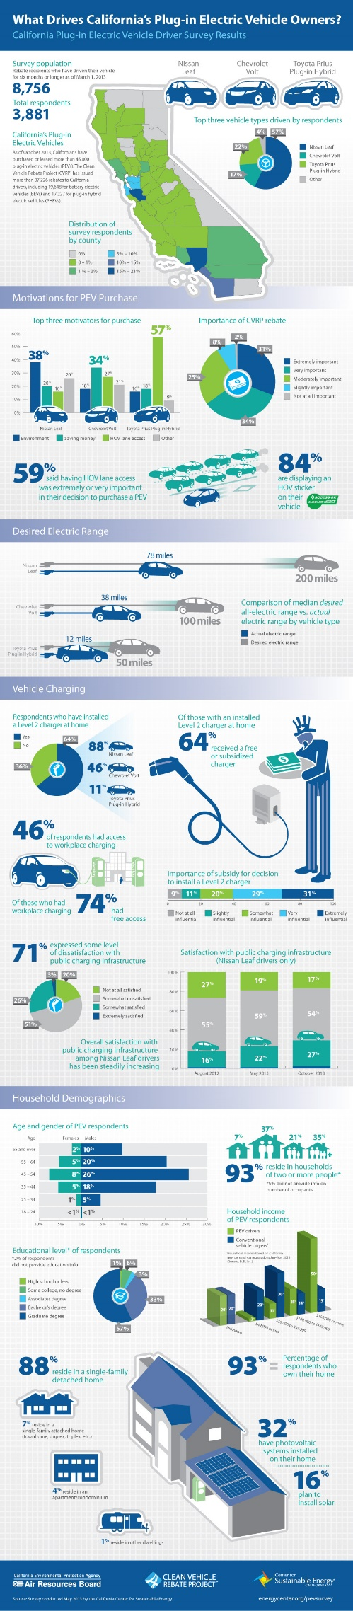](http://energycenter.org/sites/default/files/infographic_pev_survey_round3_vertical.jpg)

***PEV Owners Highly Satisfied with Driving Experiences***

The latest survey data on how California’s plug-in electric vehicle ( PEV) drivers use and charge their cars indicates that CVRP recipients are highly satisfied with their choice to go electric and use their PEVs as their primary transportation. The study shows PEV owners drive their cars an average of nearly 29 miles per day and charge their vehicles primarily at night when electrical rates are lowest.

California is the nation’s largest PEV market with some 30,000 vehicles, roughly 35 percent of the U.S. total, with sales adding about 2,500 additional cars in the state each month. The data in this survey reflects the actions of some 2,039 PEV owners throughout the state.

**Highlights from the survey include:**

* The CVRP rebate was as an important motivating factor in the purchase decision for 95% of respondents.
* PEV driver satisfaction is high, with 92% of respondents reporting overall satisfaction and driving an average of 910 miles per month.
* Driver satisfaction with public charging infrastructure remains low, but it is improving. Between February and October 2012, satisfaction increased from 17% to 23%.
* Access to workplace charging is available to 37% of survey respondents; however, 66% reported using it less than once per week when charged usage fees.
* For occasional public charging outside the home, two-thirds of respondents reported a willingness to pay up to $1.00 per hour with less than one-third willing to pay $1.50 per hour.
* For daily charging outside the home, only 16% of respondents expressed a willingness to pay up to $1.25 per hour, but 43% were willing to pay $1.00.

[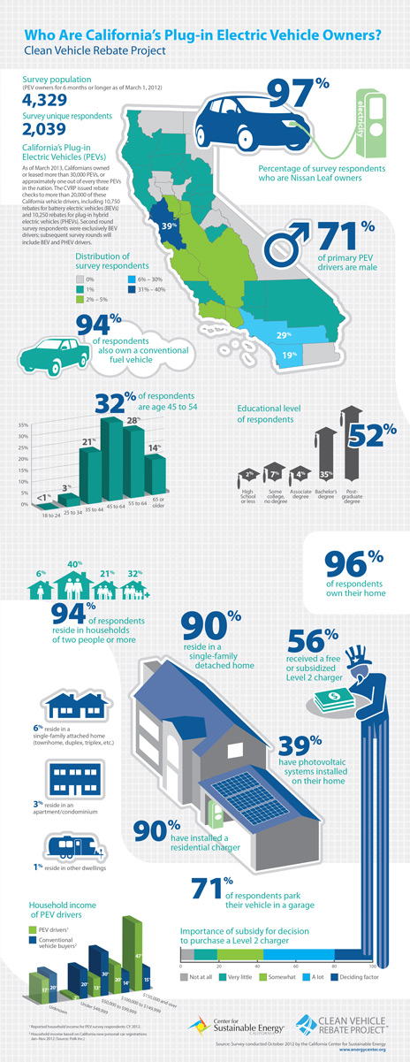](http://energycenter.org/sites/default/files/images/nav/programs/cvrp/infographics/infographic_demographics_2013_vertical.jpg)

[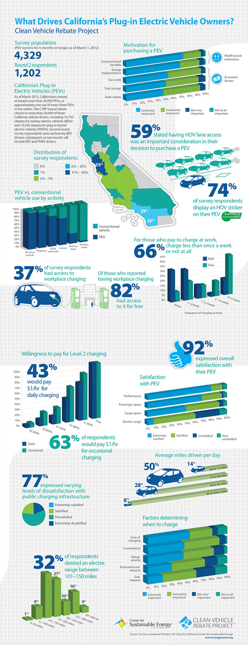](http://energycenter.org/sites/default/files/images/nav/programs/cvrp/infographics/infographic_motivations_2013_vertical.jpg)

<http://en.wikipedia.org/wiki/Plug-in_electric_vehicles_in_the_United_States#California>

<http://www.autoblog.com/2013/04/10/us-public-charging-stations-increase-by-9-in-first-quarter/>

<http://www.afdc.energy.gov/fuels/stations_counts.html>

<http://gov.ca.gov/news.php?id=17463>

<http://energycenter.org/clean-vehicle-rebate-project>

<http://www.hybridcars.com/californians-bought-more-plug-in-cars-than-china-last-year/>

<http://www.cncda.org/CMS/Pubs/Cal_Covering_4Q_14.pdf>

<http://www.navigantresearch.com/newsroom/nearly-1-in-4-plug-in-electric-vehicles-sold-in-the-united-states-from-2012-to-2020-will-be-sold-in-california>

<http://energy.gov/eere/vehicles/vehicle-technologies-office>

<http://www.its.ucdavis.edu/research/publications/publication-detail/?pub_id=2353>

<http://www.eia.gov/todayinenergy/detail.cfm?id=19131>

<http://www.electric-vehiclenews.com/2014/11/electric-vehicles-account-for-almost-10.html>

<http://www.hybridcars.com/california-leads-the-way-in-electric-vehicle-sales/>

<http://www.afdc.energy.gov/case/2023>

1. <http://energycenter.org/clean-vehicle-rebate-project/vehicle-owner-survey/feb-2014-survey>
2. <http://energycenter.org/clean-vehicle-rebate-project/vehicle-owner-survey/july-2012-survey>
3. <http://energycenter.org/clean-vehicle-rebate-project/vehicle-owner-survey/may-2013-survey>
4. <http://energycenter.org/clean-vehicle-rebate-project/vehicle-owner-survey/cvrp-final-report-2012-2013>